

ONLINE LAWYERS APPLICATION WEBSITE

LEXELITE
POWERED BY MODERN INNOVATION
Discover a powerful legal platform built for speed, efficiency, and secure connections. Find verified attorneys, book consultations, and manage your legal needs all in one
PREPARED BY: MUQADAS NIAZ
PROJECT: Semester II Final E-Project
FACULTY: SIR ARBAZ AHMED
SUBMITTED TO: Aptech Computer Education
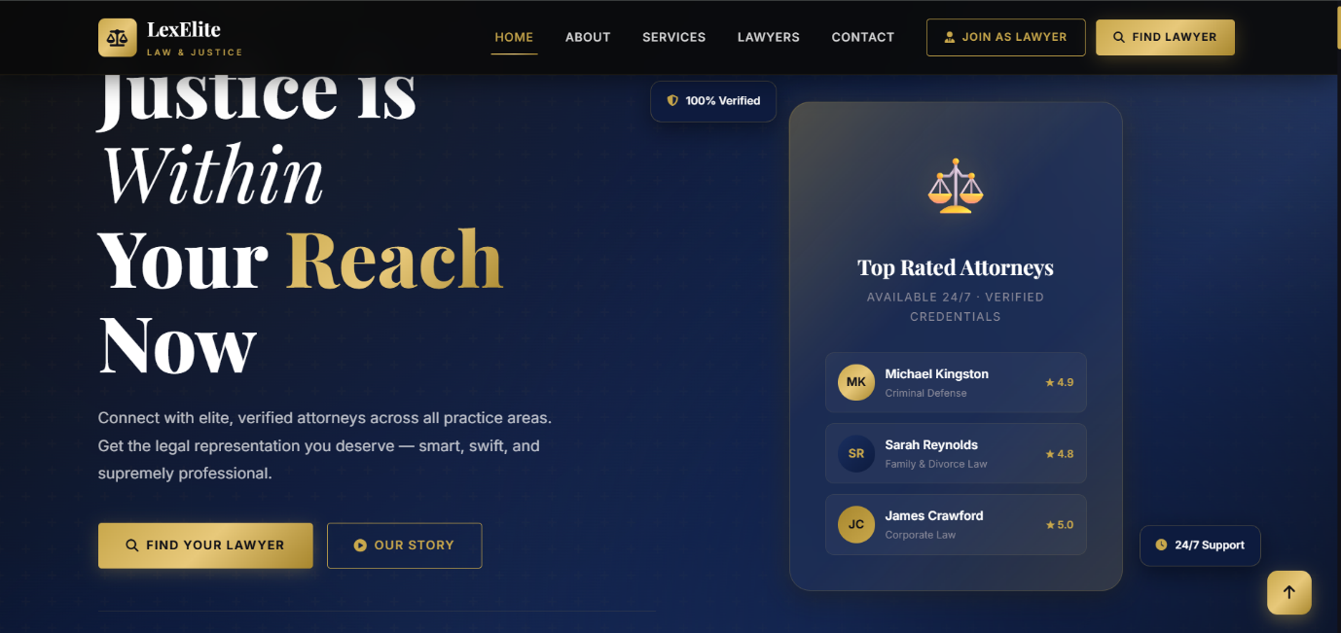



Acknowledgement
First, I would like to thank Almighty Allah for giving me the strength and ability to complete this project. I would also like to express my special thanks of gratitude to my teacher Mr Arbaz Ahmed who guided me on the project on the "Online Lawyers Application Website (Lex-Elite)" which helped me learn a great deal of new things.
I am truly thankful for the guidance and constant supervision, as well as for providing the necessary information regarding the project. Last but not the least, I would also like to thank my parents and friends who helped me a lot in finalizing this project within the limited time frame.
I also express my sincere gratitude to the E-Project team from Aptech Head Office for their valuable guidance and support. I earnestly hope that this project will provide all the necessary information required. However, suggestions and feedback for improvements will be thankfully welcomed and acknowledged.

Table of Contents
- Introduction
  - 1.1 Project Background
  - 1.2 Project Scope
- Project Objectives
- Project Overview
- Technology Stack
  - 4.1 Front-End Technologies
  - 4.2 Back-End Technologies
  - 4.3 Development Environment
- Functional Requirements
  - 5.1 Customer Module
  - 5.2 Lawyer Module
  - 5.3 Admin Module
- Non-Functional Requirements
- Database Design
  - 7.1 Database Overview
  - 7.2 ER Diagram
  - 7.3 Database Relationships
- Database Tables
  - 8.1 Admins
  - 8.2 Lawyers
  - 8.3 Customers
  - 8.4 Services
  - 8.5 Appointments
  - 8.6 Contact Messages
  - 8.7 Reviews
  - 8.8 Schedules
- System Architecture
- System Flowchart
- Output Screenshots
- Future Enhancements
- Conclusion
- References

Introduction
The Lex-Elite – Online Lawyers Application is a web-based platform developed to simplify the process of finding legal services. In the traditional system, people often face difficulties in searching for qualified lawyers, comparing their expertise, and booking appointments. This project provides a single online platform where customers can search for lawyers based on their specialization, view their profiles, and book appointments easily.
The system is developed using HTML, CSS, Bootstrap, JavaScript, PHP, and MySQL. It provides separate dashboards for Customers, Lawyers, and Administrators, allowing each user to perform tasks according to their role. Customers can register, search for lawyers, and book appointments. Lawyers can manage their profiles, schedules, and appointments, while administrators can manage users, services, appointments, and the overall system.
The main objective of this project is to make legal services more accessible, organized, and efficient through a secure and user-friendly web application.

1.1 Project Background
Nowadays, legal services are an essential part of society, but finding the right lawyer is often time-consuming and inconvenient. Many people rely on personal references or visit law firms physically, which requires significant time and effort. Similarly, lawyers face challenges in promoting their services and managing client appointments efficiently.
To overcome these issues, the Lex-Elite – Online Lawyers Application was developed. It provides a digital platform where customers can easily search for lawyers according to their specialization, view detailed profiles, and schedule appointments online. This system reduces paperwork, improves communication, and makes legal services more accessible for everyone.

1.2 Project Scope
The scope of the Lex-Elite – Online Lawyers Application is to provide a complete online platform for managing legal consultation services. The system allows customers to register, search for lawyers, book appointments, and manage their profiles. Lawyers can update their professional information, manage their schedules, and respond to appointment requests. Administrators have full control over the system, including managing lawyers, customers, services, appointments, and reports.
The project focuses on providing an efficient, secure, and user-friendly solution that improves the interaction between customers and lawyers while reducing manual processes and enhancing the overall management of legal services.

Project Objectives
The primary objective of the Lex-Elite – Online Lawyers Application is to provide an efficient and user-friendly online platform that connects customers with qualified lawyers. The system is designed to simplify the process of searching for lawyers, booking appointments, and managing legal consultation services.
The main objectives of this project are:
- To develop a secure web-based platform for online legal services.
- To allow customers to register, log in, and search for lawyers based on their specialization.
- To enable customers to book appointments with lawyers online.
- To provide lawyers with a dashboard to manage their profiles, schedules, and appointments.
- To provide an administrator panel for managing lawyers, customers, services, and appointments.
- To reduce the time and effort required to find suitable legal assistance.
- To improve communication between customers and lawyers through an organized appointment system.
- To maintain accurate and secure records of users, services, and appointments in the database.
- To provide a responsive and user-friendly interface that can be accessed from different devices.
- To minimize manual paperwork by automating the management of legal consultation services.

Project Overview
Lex-Elite – Online Lawyers Application is a web-based legal service platform designed to connect customers with qualified lawyers in a simple, secure, and efficient way. The system allows customers to search for lawyers based on their specialization, view their profiles, and book appointments online without visiting law offices physically.
The application provides three different user modules: Customer, Lawyer, and Administrator. Each module has its own dashboard and functionalities. Customers can register, log in, search for lawyers, book appointments, and manage their profiles. Lawyers can manage their professional profiles, update their availability, and handle appointment requests. The Administrator has complete control over the system, including managing lawyers, customers, services, appointments, and website content.

The system is developed using HTML, CSS, Bootstrap, JavaScript, PHP, and MySQL, providing a responsive, secure, and user-friendly interface. All information is stored in a MySQL database, ensuring efficient data management and quick access to records.
Key Features

Key Features of this E-Project

- Dynamic Public Homepage: Showcasing top-rated attorneys, platform statistics, and popular legal services.
- Dedicated User Modules: Separate secure registration and interactive dashboards for Customers and Lawyers.
- Admin Verification System: A comprehensive dashboard for managing users and manually approving/rejecting lawyers.
- Smart Search System: Advanced database-driven filtering by lawyer name, location, and practice area.
- Appointment Booking: Seamless digital scheduling with trackable statuses (Pending, Confirmed, Completed, Cancelled).
- Lawyer Schedule Management: Lawyers can manage their availability and review appointment requests directly from their dashboard.
- Secure Authentication: Encrypted data handling, secure sessions, and role-based access control.

The Lex-Elite – Online Lawyers Application aims to improve the accessibility of legal services by providing a centralized platform where customers and lawyers can interact efficiently while reducing manual work and saving time.

Technologies Stack
The Lex-Elite – Online Lawyers Application is developed using modern web technologies that provide a secure, responsive, and user-friendly environment. The technologies used in this project are described below.

4.1 Front-End Technologies

The front-end of the application is developed using:
- HTML5 – Used to create the structure of web pages.
- CSS3 – Used for styling and designing the user interface.
- Bootstrap 5 – Used to create a responsive and mobile-friendly layout.
- JavaScript – Used to add interactivity and improve the user experience.
- Font Awesome – Used for attractive icons throughout the website.
4.2 Back-End Technologies

The server-side functionality of the application is developed using:
- PHP – Handles the business logic, user authentication, and communication with the database.
- MySQL – Stores and manages all project data, including users, lawyers, services, and appointments.
4.3 Development Environment

The following tools were used during the development of the project:
- Visual Studio Code – Source code editor.
- XAMPP – Local server environment including Apache and MySQL.
- phpMyAdmin – Database management tool.
- Google Chrome – Used for testing and debugging the application.
- Git & GitHub – Used for version control and project backup.

Functional Requirements
Functional requirements describe the features and operations that the Lex-Elite – Online Lawyers Application must perform. The system provides different functionalities for Customers, Lawyers, and the Administrator to ensure smooth and efficient management of legal services.

5.1 Customer Module

The Customer Module allows users to access legal services through the platform. The customer can:
Register a new account.
Log in securely.
Search lawyers by name, specialization, or location.
View lawyer profiles and consultation details.
Book appointments with lawyers.
View appointment history and status.
Update personal profile information.
Submit reviews and ratings after completed appointments.
Contact the administrator through the contact form.

5.2 Lawyer Module

The Lawyer Module enables lawyers to manage their professional profiles and appointments. A lawyer can:
Register and log in securely.
Update profile information and professional details.
Manage availability and consultation schedule.
View appointment requests.
Accept or reject appointment requests.
Update appointment status.
View completed appointments.
Manage offered legal services.
Update account settings.

5.3 Admin Module
The Admin Module provides complete control over the application. The administrator can:
Log in securely.
Approve or reject lawyer registrations.
Manage customer accounts.
Manage lawyer accounts.
Add, edit, and delete legal services.
Manage appointments.
View dashboard statistics and reports.
Manage contact messages.
Monitor system activities.
Maintain the overall functionality and security of the application.

Non-Functional Requirements
Non-functional requirements define the quality, performance, and security standards of the Lex-Elite – Online Lawyers Application. These requirements ensure that the system is reliable, secure, and easy to use.
- Performance: The system should load pages quickly and respond efficiently to user requests.
- Security: User data should be protected through secure authentication, session management, and role-based access control.
- Reliability: The application should perform consistently without errors and ensure accurate data processing.
- Usability: The system should have a simple, user-friendly, and responsive interface that is easy for all users to navigate.
- Availability: The application should be available whenever users need to access legal services, except during scheduled maintenance.
- Scalability: The system should support future enhancements, additional users, and new features without major changes.
- Maintainability: The source code should be well-structured and easy to update, debug, and maintain.
- Compatibility: The application should work properly on modern web browsers such as Google Chrome, Microsoft Edge, Mozilla Firefox, and Safari.
- Data Integrity: The database should maintain accurate, consistent, and valid information always.

Database Design

The Lex-Elite – Online Lawyers Application uses a MySQL relational database to store and manage all application data efficiently. The database is designed to maintain data integrity, reduce redundancy, and establish relationships between different modules of the system. It stores information related to administrators, lawyers, customers, services, appointments, contact messages, and reviews.

7.1 Database Overview:

The database is the backbone of the application. It stores all user information, appointment records, legal services, reviews, and contact messages. Each table has a unique primary key, and relationships are maintained using foreign keys to ensure accurate and consistent data.
The main database tables used in this project are:

- admins
- lawyers
- customers
- services
- appointments
- contact messages
- reviews
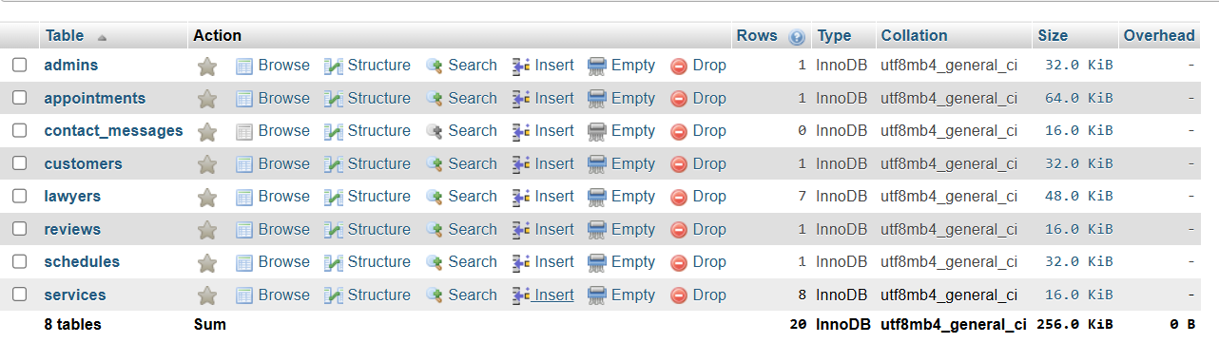
- schedules

7.2 Entity Relationship (ER) Diagram:

The Entity Relationship (ER) Diagram illustrates how different tables in the database are connected. It shows the relationships between customers, lawyers, services, appointments, reviews, and contact messages, ensuring proper data flow throughout the application.

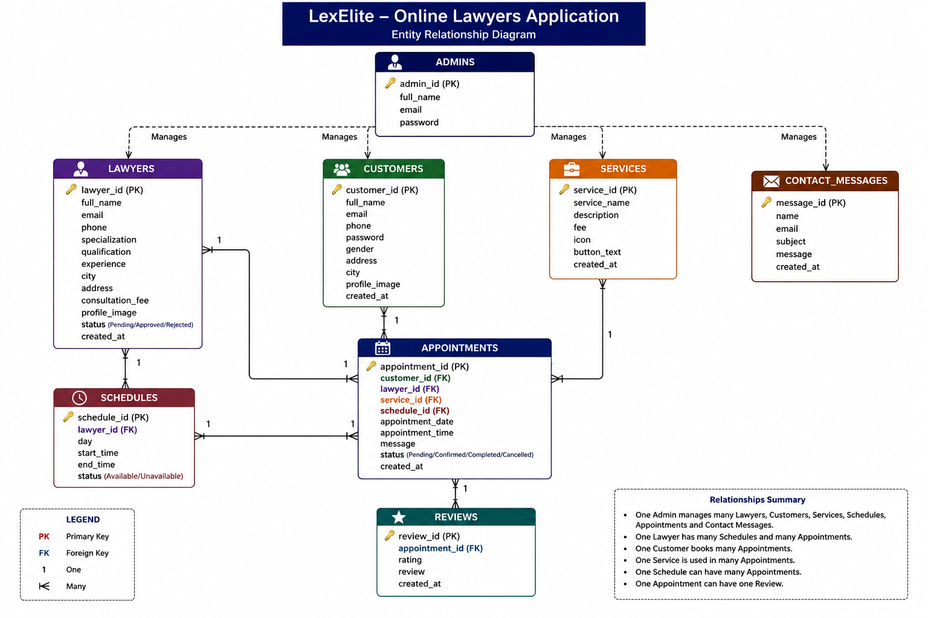

7.3 Database Relationships

The relationships between the database tables are as follows:
- One Customer can book multiple appointments.
- One Lawyer can receive multiple appointments.
- One Service can be selected for multiple appointments.
- One Appointment belongs to one customer, one lawyer, and one service.
- One Appointment can have one review submitted by the customer.
- The Administrator manages lawyers, customers, services, and appointments through the admin panel.

Database Tables

8.1 Admins Table

The admins table stores the administrator login credentials and information required to manage the entire system
Admin table | Description
Admin id | Primary key
Full name | Admin name
Email | Admin email
Password | Admin login password
Created at | Record creation date



8.2 Lawyers Table

The lawyers table stores all registered lawyer information, including their personal details, specialization, consultation fee, and account status.
lawyer table | Description
Lawyer id | Primary key
Full name | Lawyer name
Email | Email address
Phone | Contact number
Password | Login password
Specialization | Area of practice
Qualification | Educational Qualification
Experience | Years of Experience
City | City
Address | Office address
CNIC NO | CNIC number
Bio | Lawyer biography
Consultation fee | fee which decides lawyer
Profile image | Lawyer image
Status | Approval status
Created at | Registration date

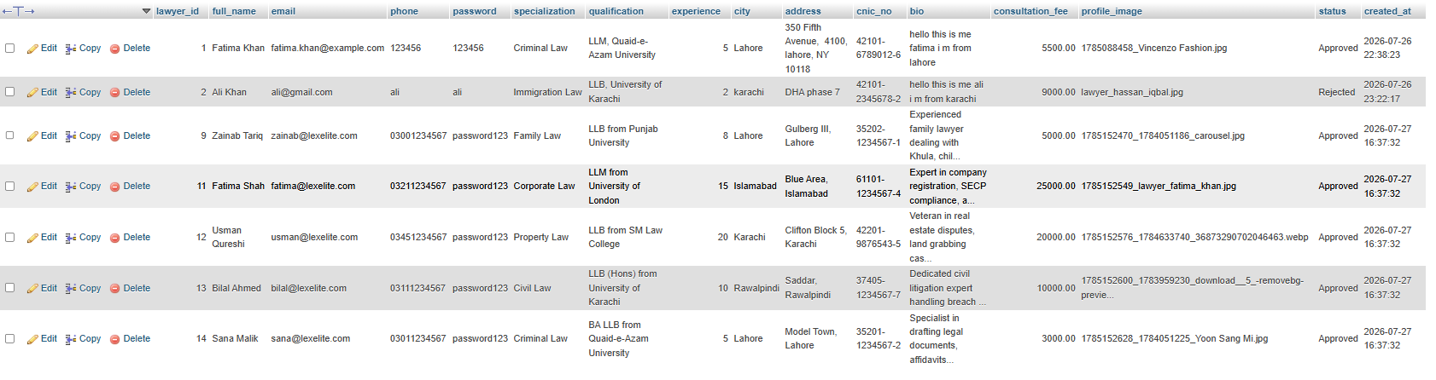
8.4 Services Table

The services table stores all legal services offered on the platform.
Service table | Description
Service id | Primary key
Service name | Service name
Description | Service description
Fee | Consultation fee
Service number | Service number

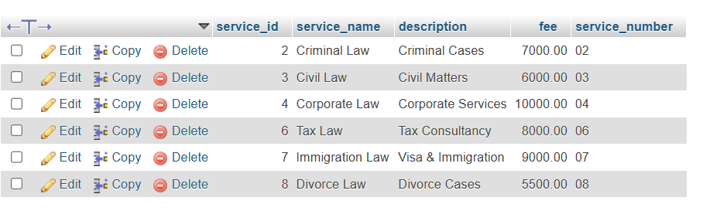

8.5 Schedules Table

The schedules table stores lawyer availability for appointment booking.
Schedule table | Description
Schedule id | Primary key
Lawyer id | Foreign key
Day | Availability day
Start time | Starting time
End time | Ending time
Status | Availability status



8.6 Appointments Table

The appointments table stores appointment records between customers and lawyers.
Appointment Table | Description
Appointment Id | Primary Key
Customer Id | Foreign Key
Lawyer Id | Foreign Key
Service Id | Foreign Key
Appointment Date | Appointment Date
Appointment Time | Appointment Time
Message | Customer Message
Status | Appointment Status
Created At | Record Creation Date

8.7 Reviews Table

The reviews table stores customer ratings and feedback after completed appointments.
Reviews Table | Description
Review Id | Primary Key
Appointment Id | Foreign Key
Rating | Customer Rating
Review | Customer Review
Created At | Review Date



8.8 Contact Messages Table

The contact messages table stores messages submitted through the Contact Us page.

contact messages Table | Description
message id | Primary Key
name | sender name
email | sender email
subject | message subject
message | message content
Created At | submission date

System Architecture

The Lex-Elite – Online Lawyers Application follows a three-tier architecture, which separates the application into three distinct layers: the Presentation Layer, the Application Layer, and the Database Layer. This architecture improves system performance, maintainability, security, and scalability.
The application allows Customers, Lawyers, and Administrators to interact with the system through a web browser. User requests are processed by the PHP backend, which communicates with the MySQL database to retrieve or store data before displaying the response.

9.1 Architectural Overview

The system architecture consists of the following layers:

Presentation Layer (User Interface)

The Presentation Layer is responsible for displaying the website interface to users. It is developed using HTML5, CSS3, Bootstrap 5, JavaScript, and Font Awesome. This layer provides responsive pages for Customers, Lawyers, and Administrators.

Application Layer (Business Logic)

The Application Layer is developed using PHP. It handles user authentication, form validation, appointment management, lawyer approval, service management, and communication between the user interface and the database.

Database Layer

The Database Layer uses MySQL to store and manage all application data, including administrator records, customer information, lawyer profiles, services, schedules, appointments, reviews, and contact messages

9.2 Request–Response Cycle

The request–response cycle describes how data flows through the application.

- The user accesses the website using a web browser.
- The user performs an action such as login, registration, searching for a lawyer, or booking an appointment.
- The request is sent to the PHP application.
- PHP validates the request and interacts with the MySQL database.
- The database returns the requested data.
- PHP processes the data and generates the appropriate response.
- The final response is displayed to the user through the web browser.

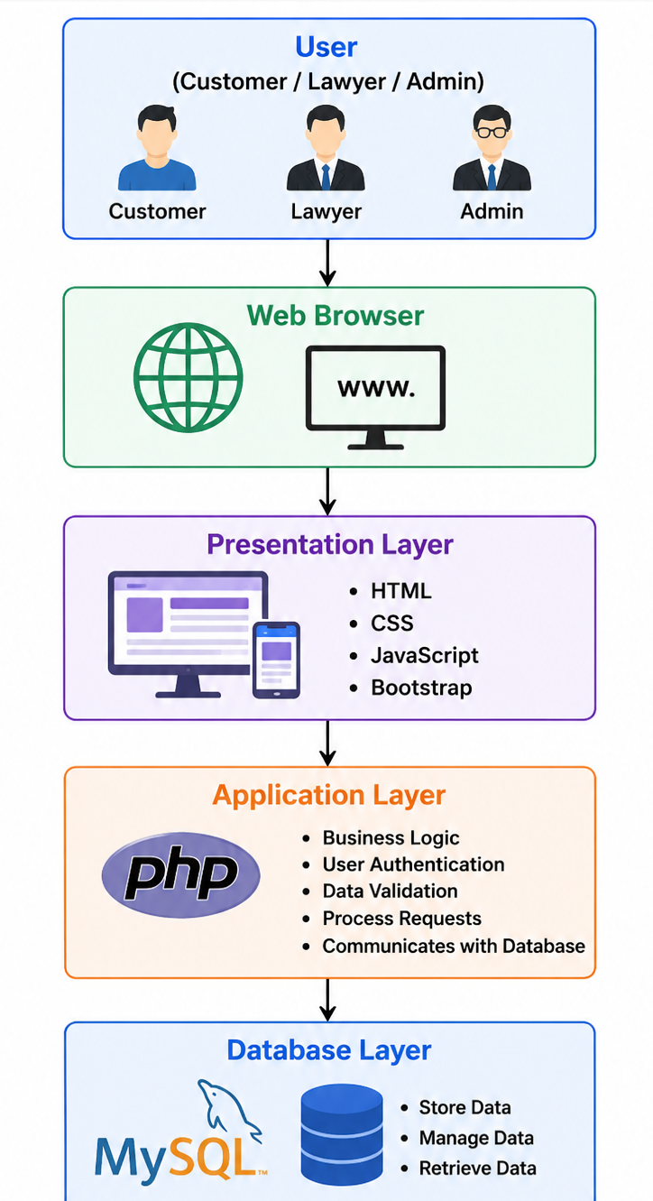

System flowchart

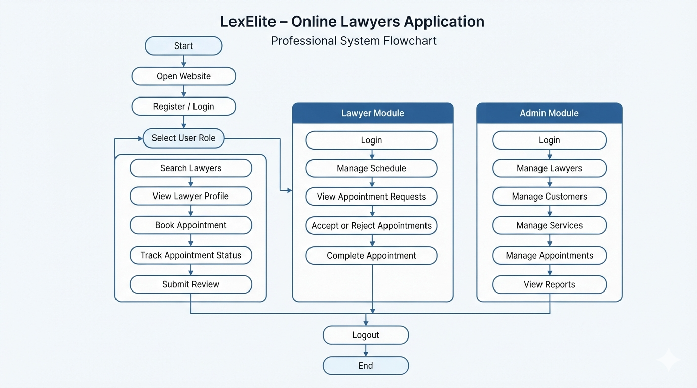

Output screenshots

Home page:


About Page:

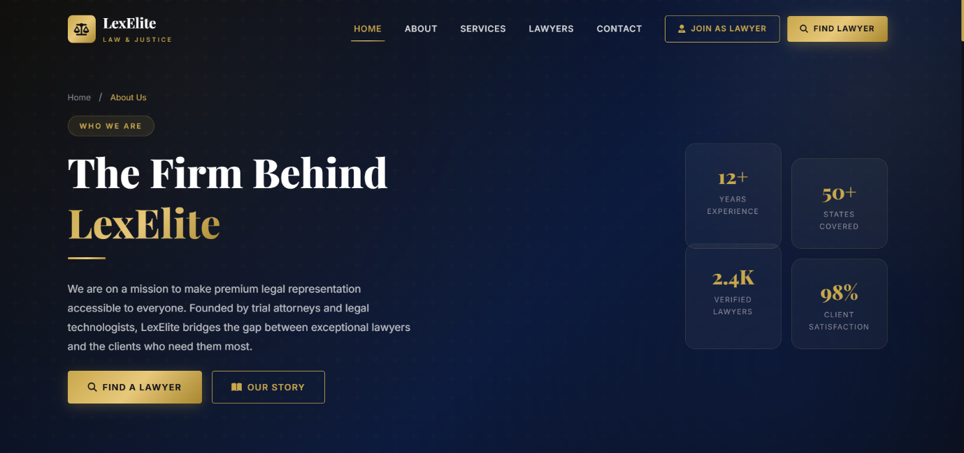

Services Page:

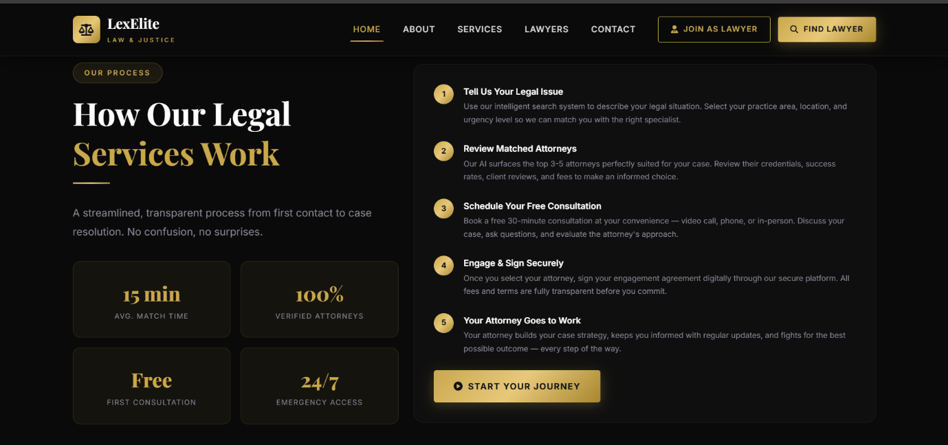

Find lawyers Page:



Contact section:

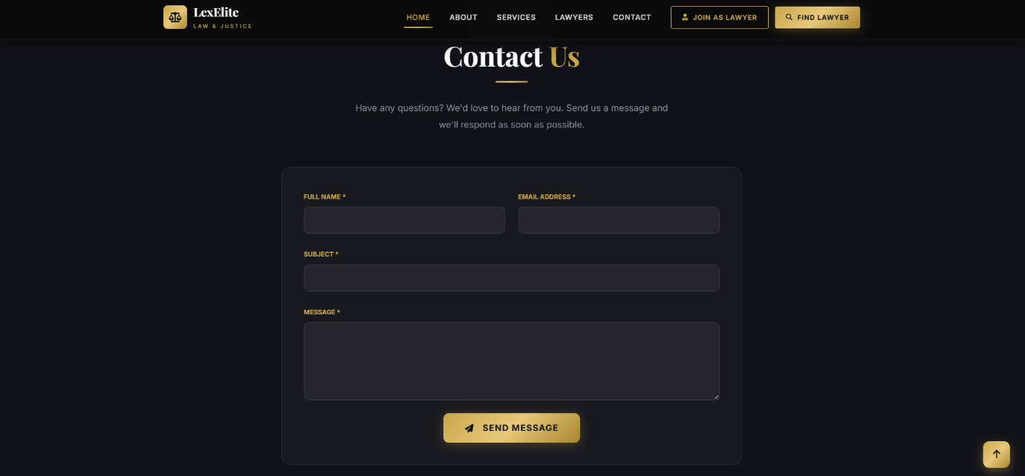

Admin dashboard:

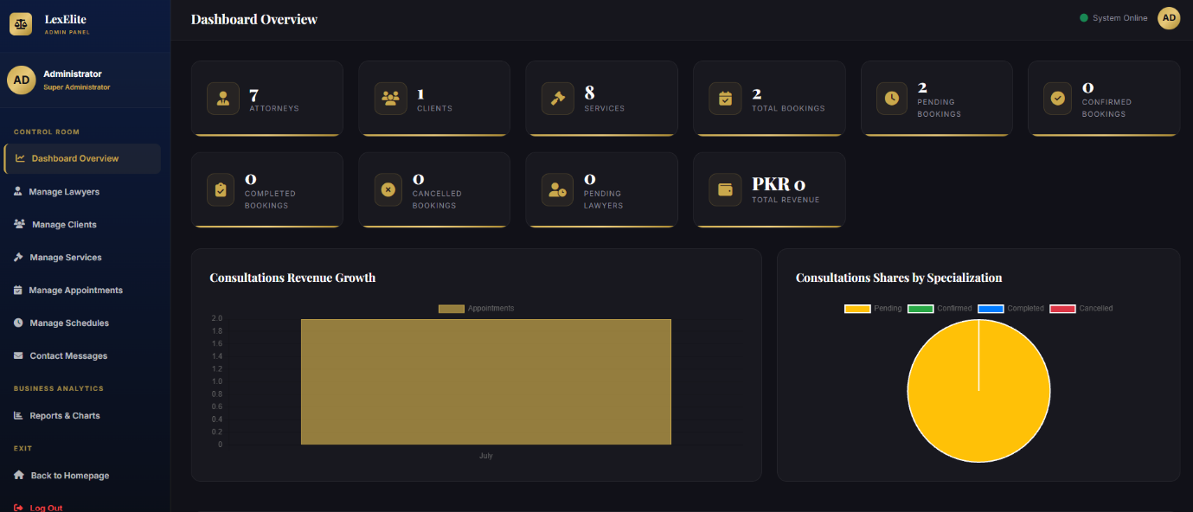

Lawyer dashboard:

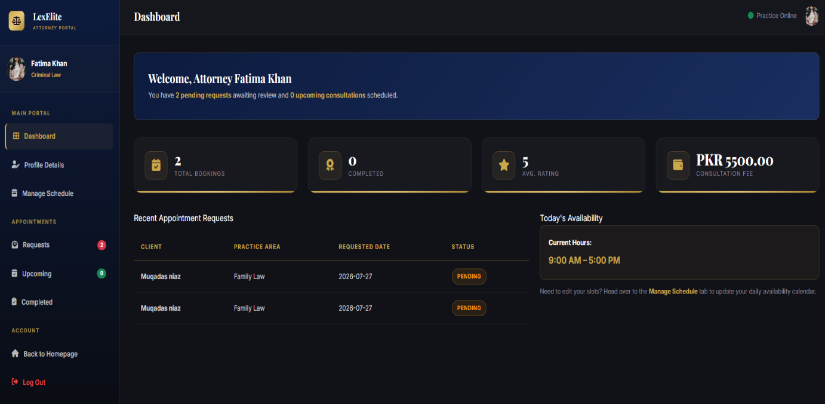

Customer dashboard:

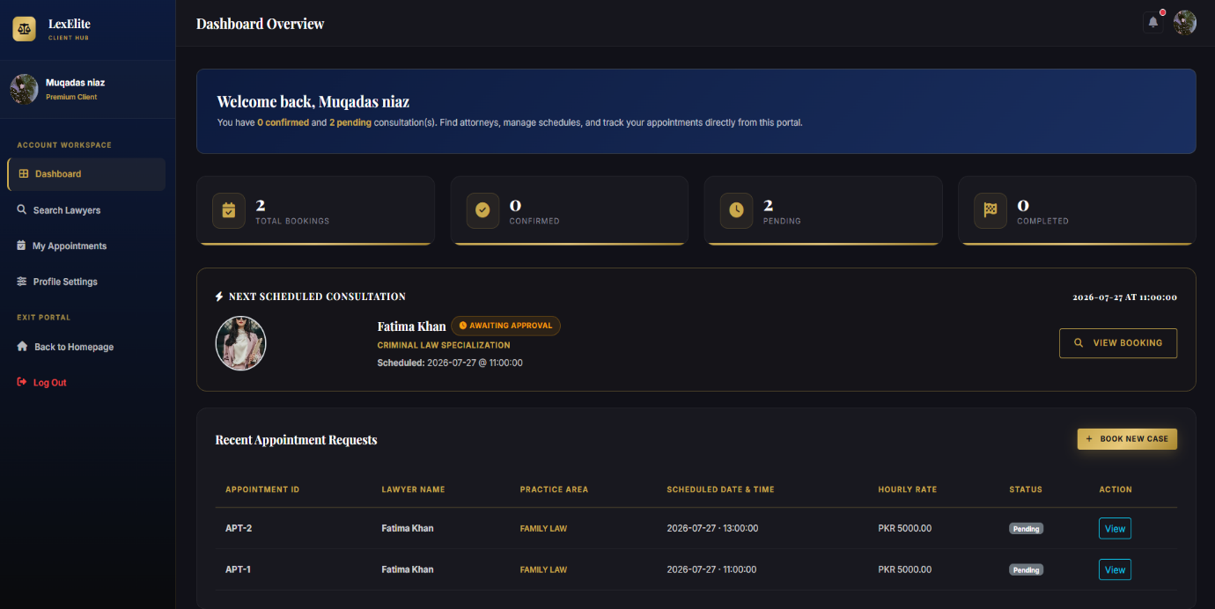

Future Enhancements
The Lex-Elite – Online Lawyers Application can be further improved by adding advanced features to enhance user experience and system functionality. Some possible future enhancements are:
- Integration of online payment gateways for consultation fee payments.
- Real-time chat and video consultation between customers and lawyers.
- Email and SMS notifications for appointment confirmations and reminders.
- AI-based lawyer recommendation based on customer requirements.
- Mobile application for Android and iOS platforms.
- Online document upload and sharing for legal cases.
- Multi-language support to serve users from different regions.
- Advanced analytics and reporting for administrators.
- Two-factor authentication (2FA) for enhanced account security.
- Cloud deployment for improved performance and scalability.

Conclusion

The Lex-Elite – Online Lawyers Application is a secure and user-friendly web-based platform that simplifies the process of connecting customers with qualified lawyers. The system provides separate modules for Customers, Lawyers, and Administrators, enabling efficient management of appointments, legal services, schedules, and user information.
The project successfully achieves its objectives by providing an organized digital solution for legal consultation services. It reduces manual work, improves communication, enhances data management, and offers a responsive interface for users. Overall, the application demonstrates the practical implementation of web development technologies to solve real-world problems in the legal services sector.

References
The following resources were used during the development of this project:
- PHP Official Documentation
- MySQL Official Documentation
- Bootstrap 5 Documentation
- HTML5 Documentation
- CSS3 Documentation
- JavaScript (MDN Web Docs)
- Font Awesome Documentation
- Visual Studio Code Documentation
- XAMPP Documentation
- phpMyAdmin Documentation

THANK YOU

I would like to express my sincere gratitude to Allah Almighty for granting me the strength, patience, and guidance to successfully complete this project.

I am also deeply thankful to my respected teachers and mentors at Aptech for their continuous support, valuable guidance, and encouragement throughout the development of this project. Their knowledge and constructive feedback helped me improve my technical and problem-solving skills.

A special thanks to my family and friends for their constant motivation, understanding, and support during every stage of this project.

Finally, I would like to thank everyone who contributed directly or indirectly to the successful completion of the Lex-Elite Online Lawyers Application.

Thank you for your time and consideration.

"Thank You for Reviewing Our Project"
Lex-Elite – Online Lawyers Application

